Lab 5: MySQL & PHP
Prepared: TrangNTT
Lab 6-1. MySQL & PHP 1
6.1. Configure MySQL Server Instance 2
6.2. Use MySQL Command Line Client to investigate the mysql database 7
6.3. Run the example in the lecture slides 10
6.4. Open and use phpMyAdmin to create a database and tables 13
6.5. Category Administration page 14
6.6. Business Registration page 15
6.7. Business Listing page 15

Configure MySQL Server Instance
Select Start → All Programs → Zend Server Comminity Edition → MySQL
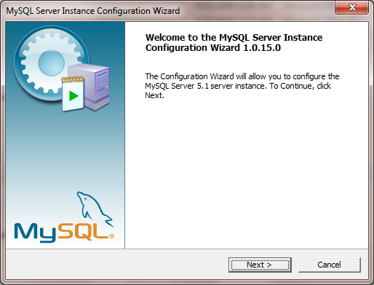
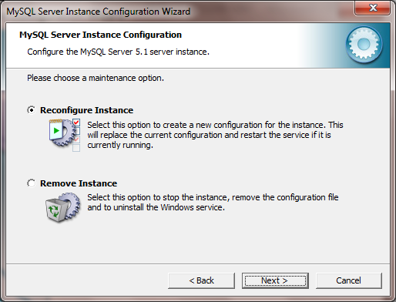
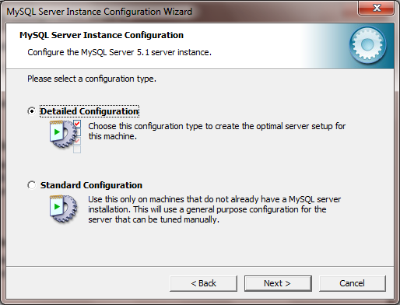
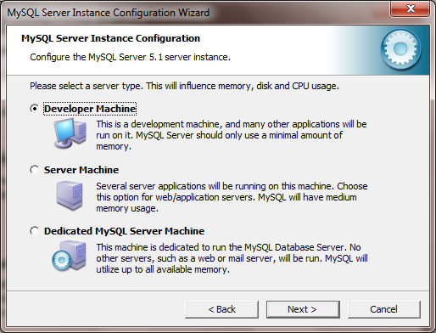
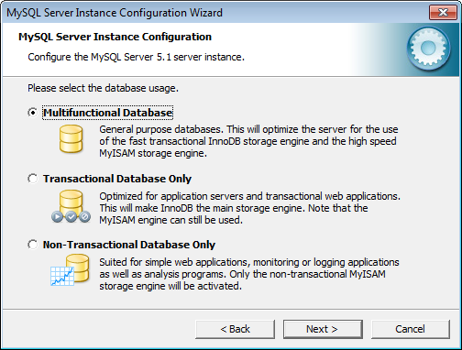
Press Modify button if you need to change the location of InnoDB tablespace.
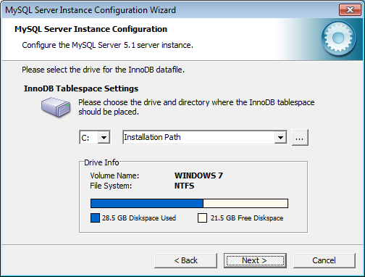
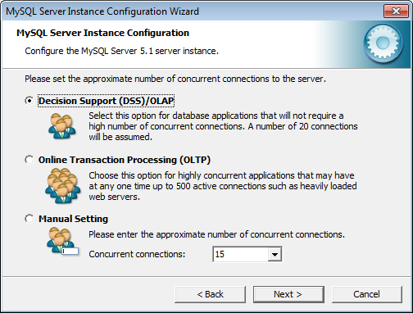
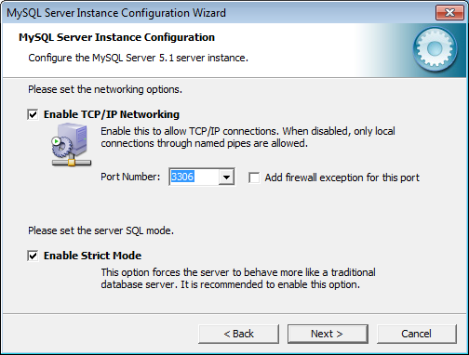
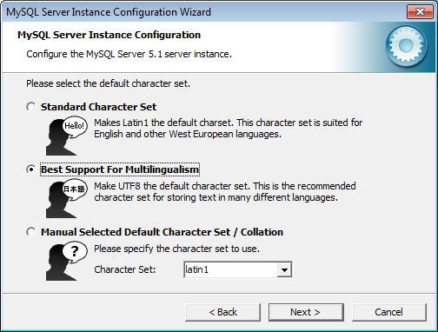
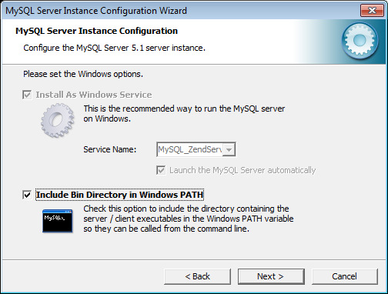
Type password for root:
- Current password: Leave blank
- New password & confirm: 123456
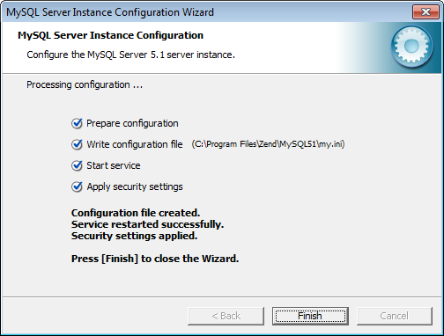

Use MySQL Command Line Client to investigate the mysql database

Change password for root username (if necessary)
- Select Start → All Programs → Zend Server Comminity Edition → MySQL Server 5.1 → MySQL Command Line Client. Enter password and press Enter.
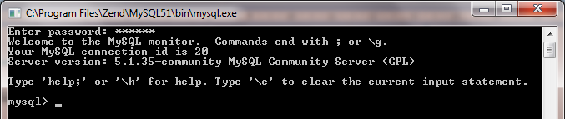
- Type: SET PASSWORD = PASSWORD('new_pass'); to change password for root.
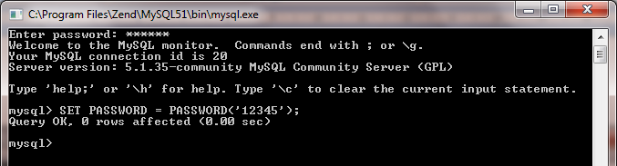

Investigate mysql database
- Show and use mysql database
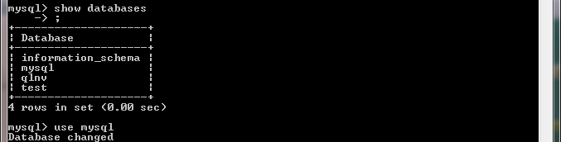
- Display all tables in the mysql database
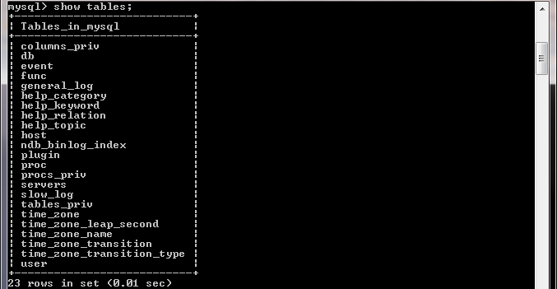
- View column details for user table
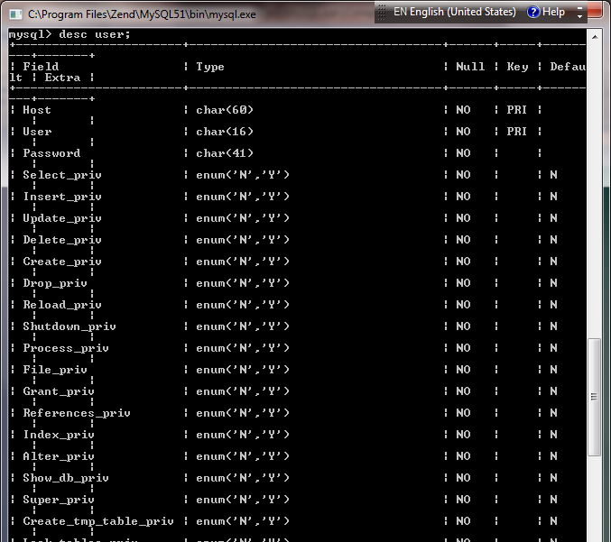
- Create database named sale to run examples from the lecture.
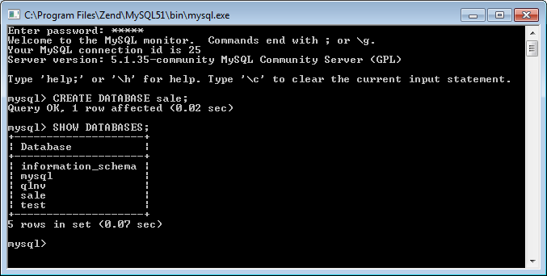

Run the example in the lecture slides

Create table Products using PHP scripts
1. <html><head><title>Create Table</title></head><body>
2. <?php
3. $server = 'localhost';
4. $user = 'phppgm';
5. $pass = 'mypasswd';
6. $mydb = 'mydatabase';
7. $table_name = 'Products';
8. $connect = mysql_connect($server, $user, $pass);
9. if (!$connect) {
10. die ("Cannot connect to $server using $user");
11. } else {
12. $SQLcmd = "CREATE TABLE $table_name(
ProductID INT UNSIGNED NOT NULL
AUTO_INCREMENT PRIMARY KEY,
Product_desc VARCHAR(50),
Cost INT,
Weight INT,
Numb INT)";
13. mysql_select_db($mydb);
14. if (mysql_query($SQLcmd, $connect)){
15. print '<font size="4" color="blue" >Created Table';
16. print "<i>$table_name</i> in database<i>$mydb</i><br></font>";
17. print "<br>SQLcmd=$SQLcmd";
18. } else {
19. die ("Table Create Creation Failed SQLcmd=$SQLcmd");
20. }
21. mysql_close($connect);
22. }
23. ?></body></html>

The result after creating table successfully:
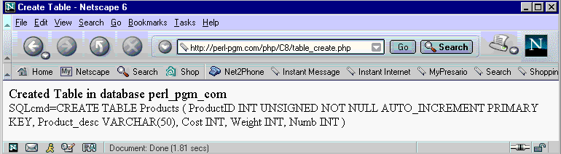

Insert data to Products
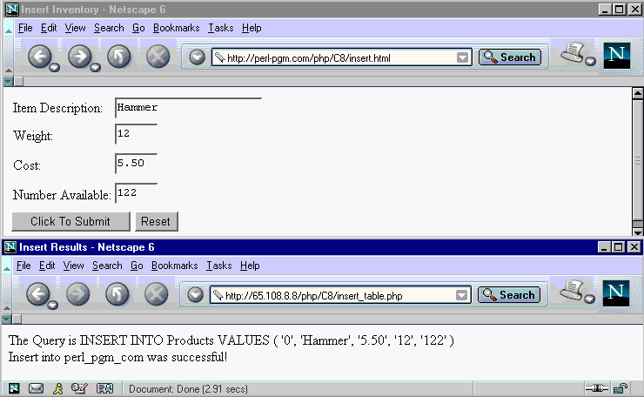

Display list of products
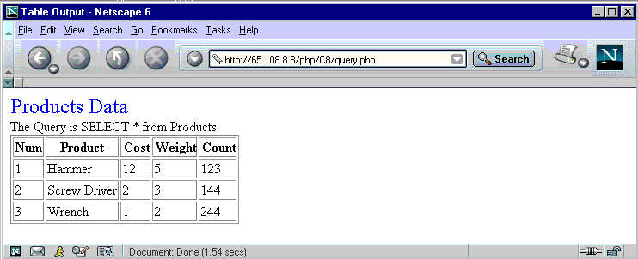

Search products
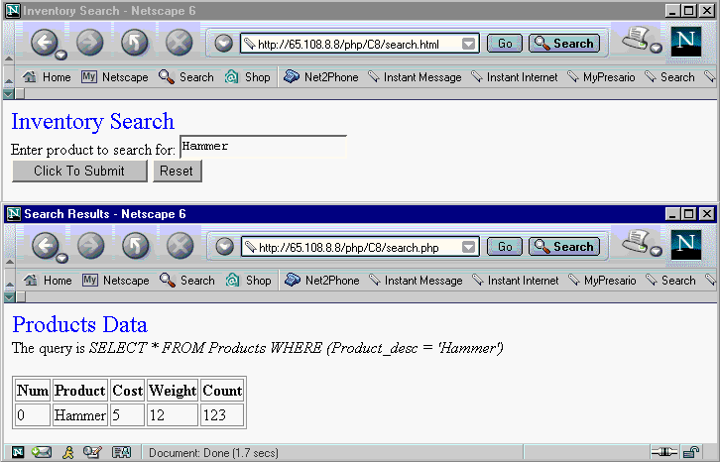

Update product
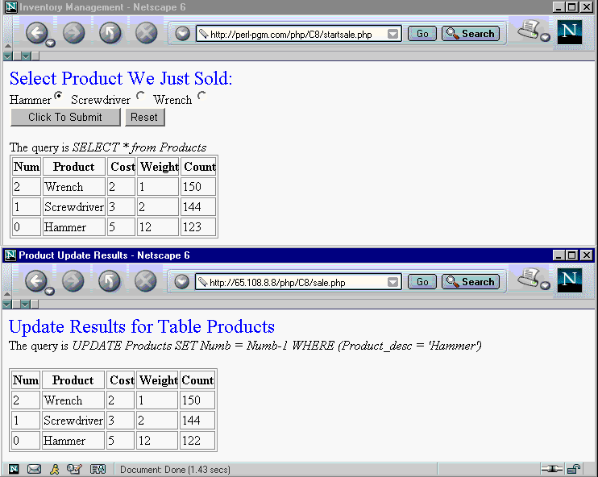

Open and use phpMyAdmin to create a database and tables

Open Zend Server Comminity Edition
- Select Start → All Programs → Zend Server Comminity Edition → Zend Server 4.0
- Enter password you setted when installing
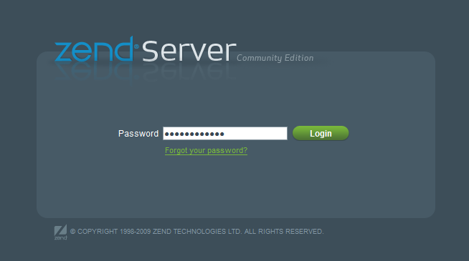

Open phpMyAdmin
- Press Login to go to Zend Server page. Click on Open phpMyAdmin
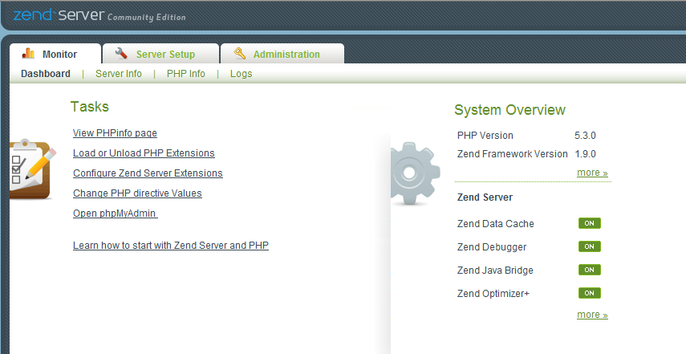
- Enter username (root) and password (123456)
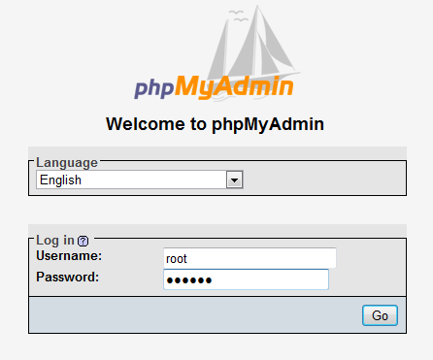

Create tables and relationships for business listing service
Create a database named business_service. Create tables and relationships as the following design:
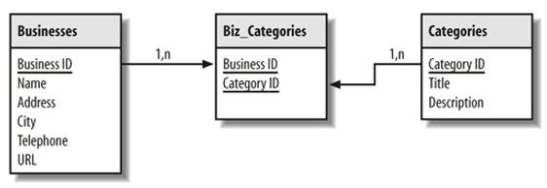

Category Administration page
Design the following page for Category Adminstration to add a category:
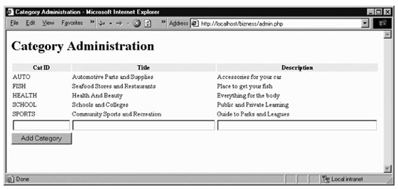

Business Registration page
Design the following page for Business Registration to add a business. Users can choose multiple categories for the business in the list in the left of the page.
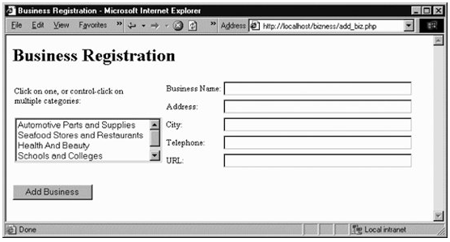
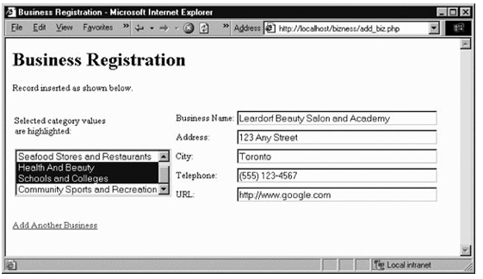

Business Listing page
Design the following page for Business Listing to display a list of businesses for a specific category. Users can click to the list of categories in the left view the list of corresponding businesses.
